Static Web Design using HTML
LAB # 02



Spring 2024
CSE-403L Database Management Systems Lab

Submitted by: Ali Asghar
Registration No.: 21PWCSE2059
Class Section: C

“On my honor, as student of University of Engineering and Technology, I have neither given nor received unauthorized assistance on this academic work.”

Submitted to:
Engr. Sumayyea Salahuddin

Date:
7th March 2024

Department of Computer Systems Engineering
University of Engineering and Technology, Peshawar
Objectives:
This lab aims at the understanding of:
- The basic syntax and structure of HTML.
- Identify the different types of headings and the appropriate usage for each.
- Understand how to create and use rules to style HTML elements.
- Learn how to use comments in HTML to provide additional information and context for the code.
- Understand how to structure paragraphs in HTML and use appropriate formatting tags.
- Understand how to use HTML styles to change the appearance of text and other elements.
- Learn how to create and format tables in HTML.
- Learn how to create and format lists in HTML.
- Understand how to create and use forms to collect user input.

Task 2.1:
1. How HTML can be helpful for a SQL/NoSQL database? Write a short note on the paper.
Ans: HTML serves as a crucial bridge between users and databases, whether you’re dealing with SQL or NoSQL systems. In the context of SQL databases, HTML helps create user interfaces by enabling forms for data input. When users submit forms (such as login or registration), the server-side code processes the data and interacts with the SQL database. For NoSQL databases, HTML plays a role in building dynamic web pages that display data from unstructured or semi-structured sources. Whether it’s rendering JSON data from a document-oriented NoSQL database or creating real-time interfaces, HTML ensures seamless interaction with databases.

2. Hands-On: Understand and go through all the examples provided in this lab. Try each one in your favorite IDE. Check output in browser and try to make some changes from your own.

Example 1:
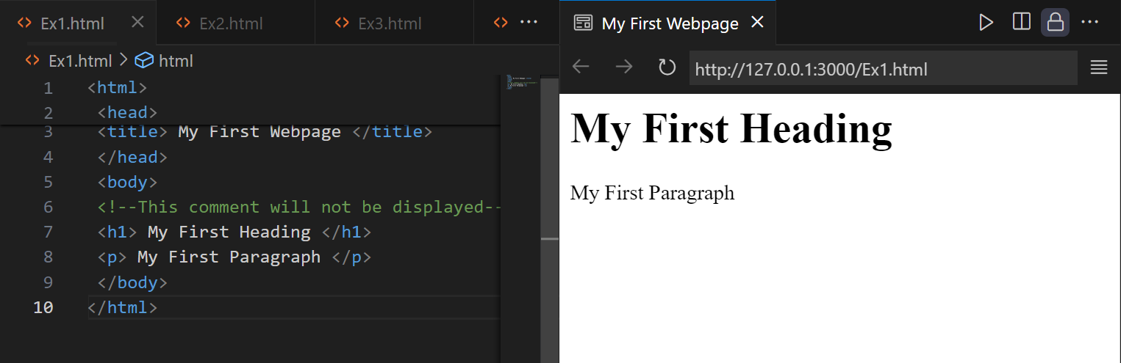

Example 2:
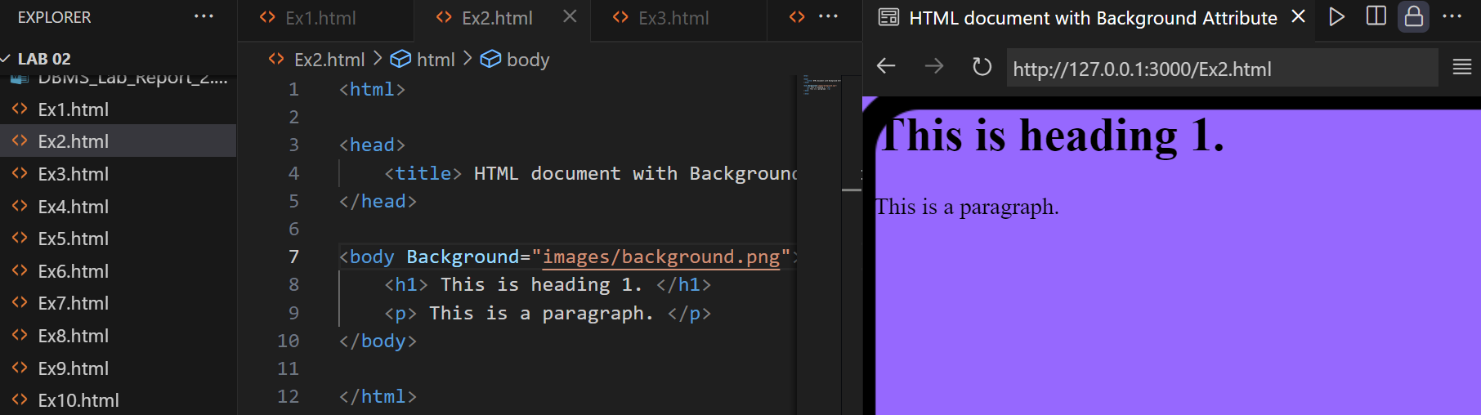
Example 3:
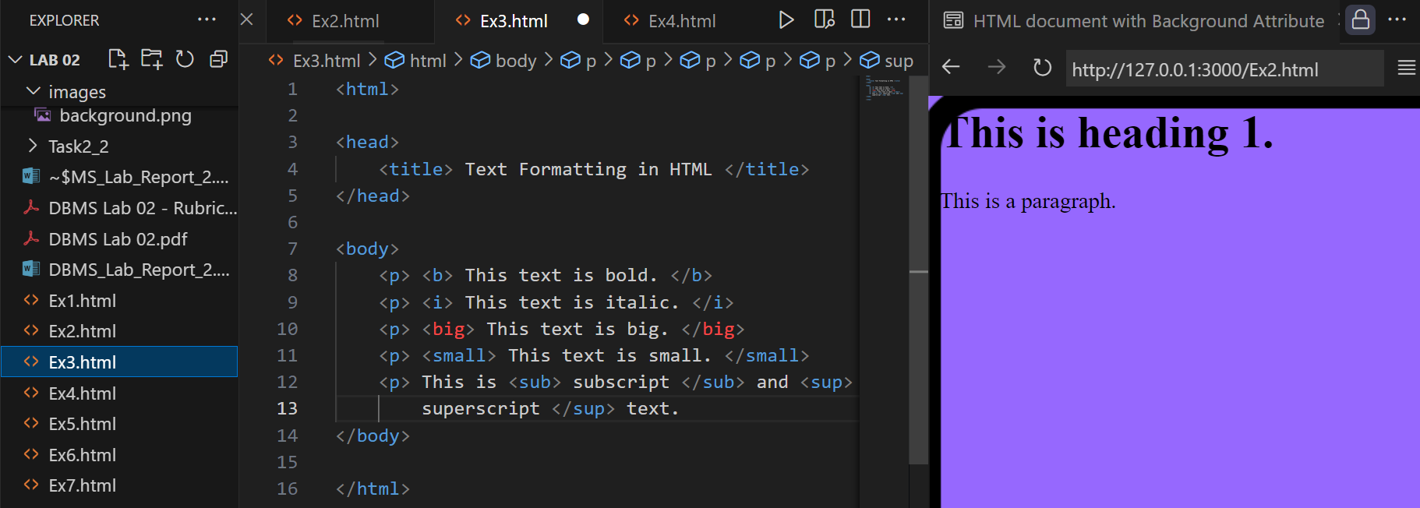
Example 4:
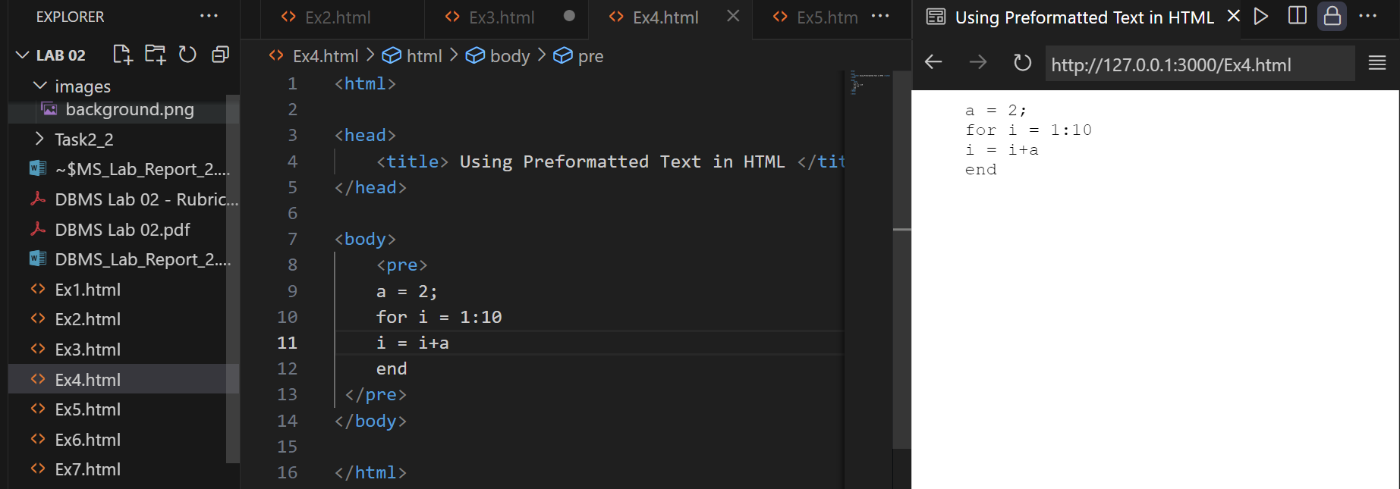

Example 5:
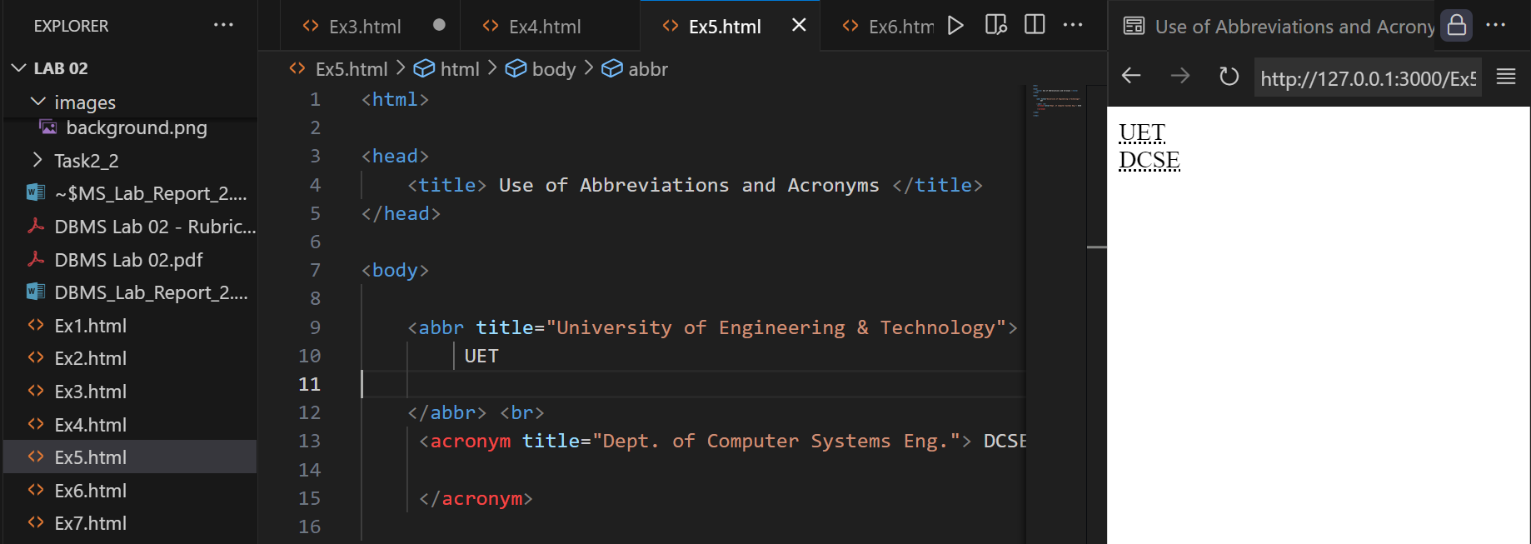
Example 6:
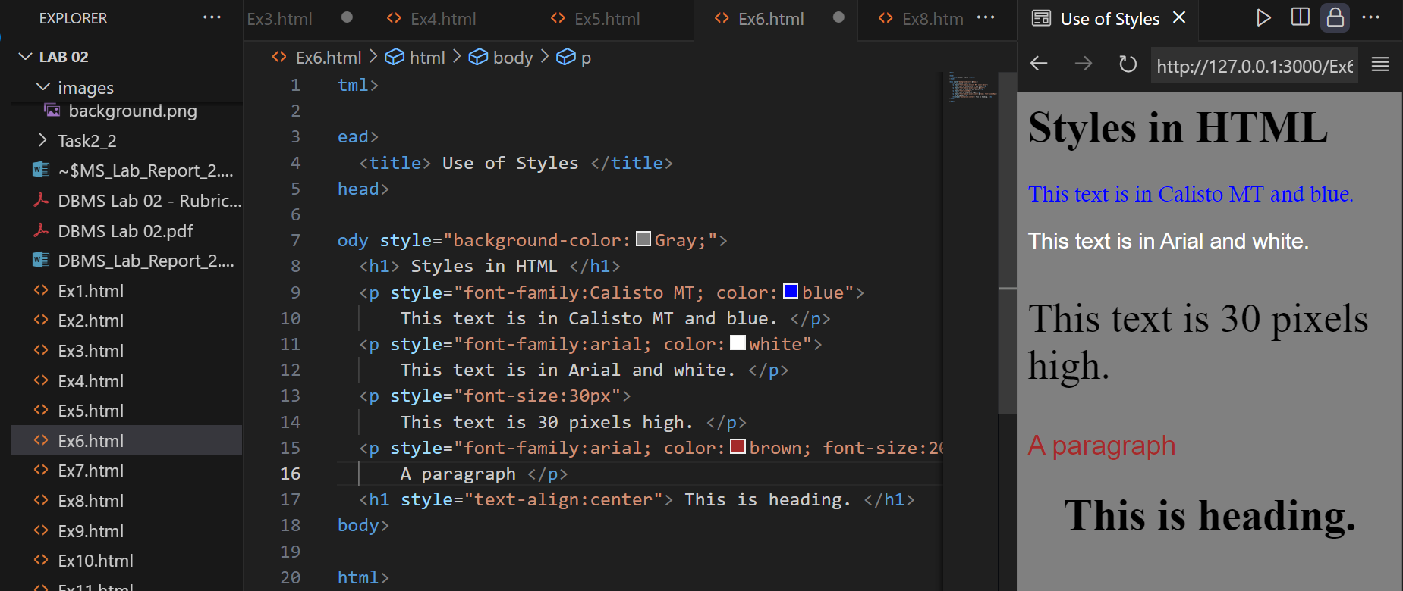
Example 7:
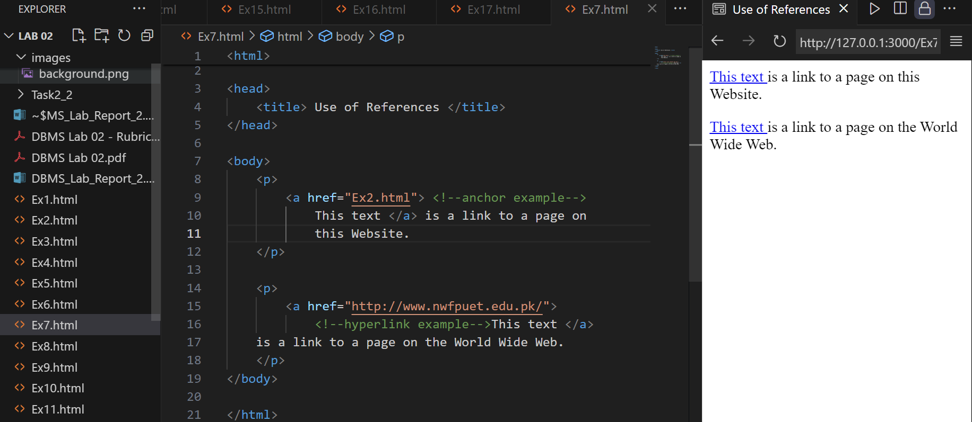
Example 8:
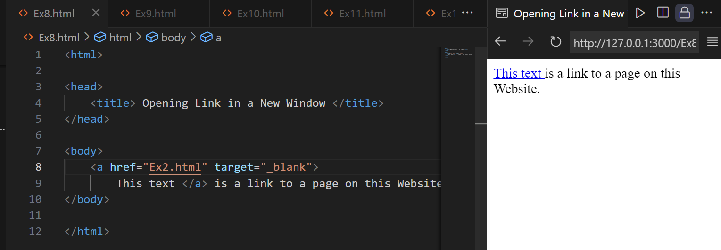
Example 9:
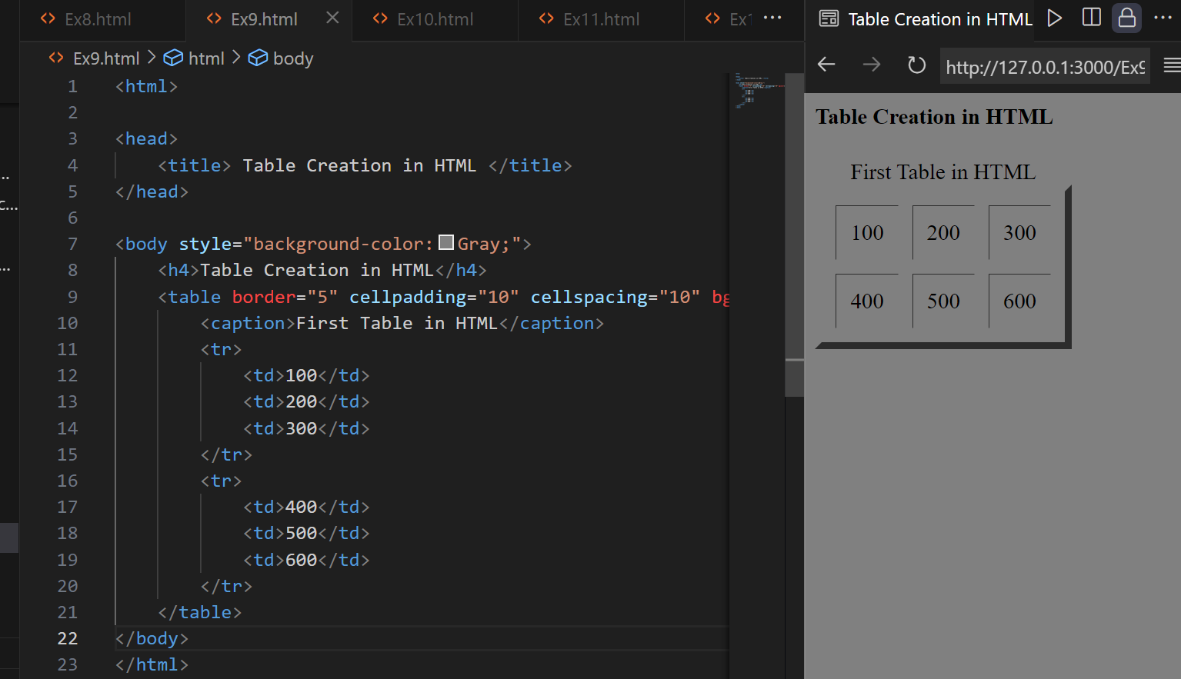
Example 10:
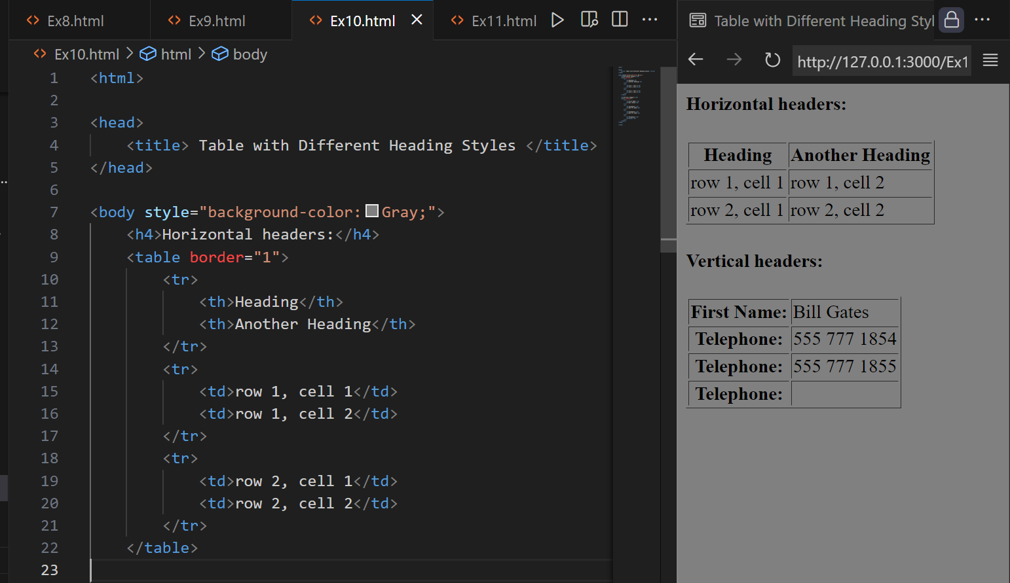
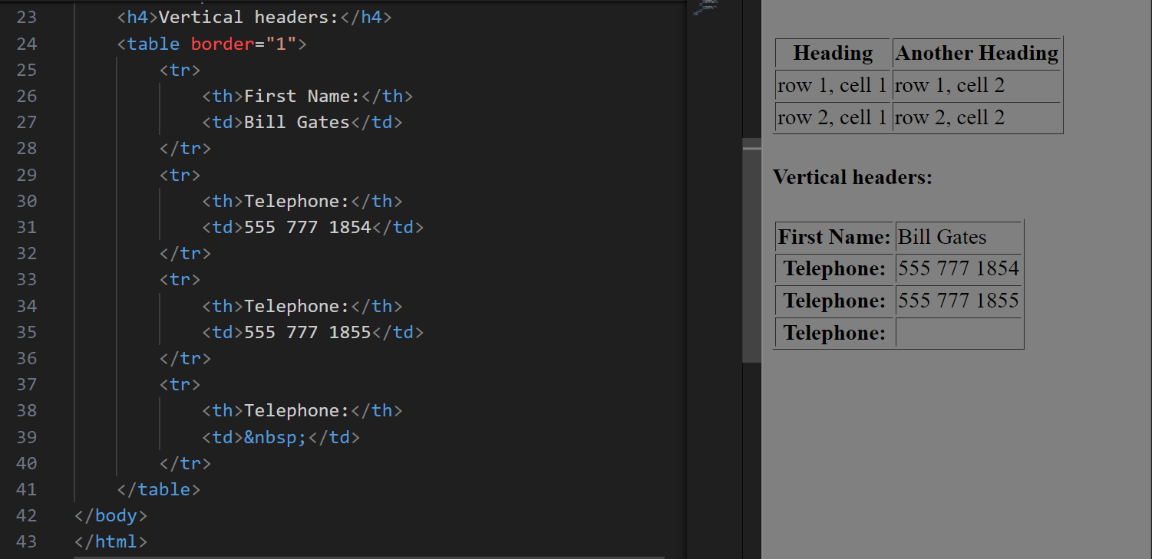

Example 11:
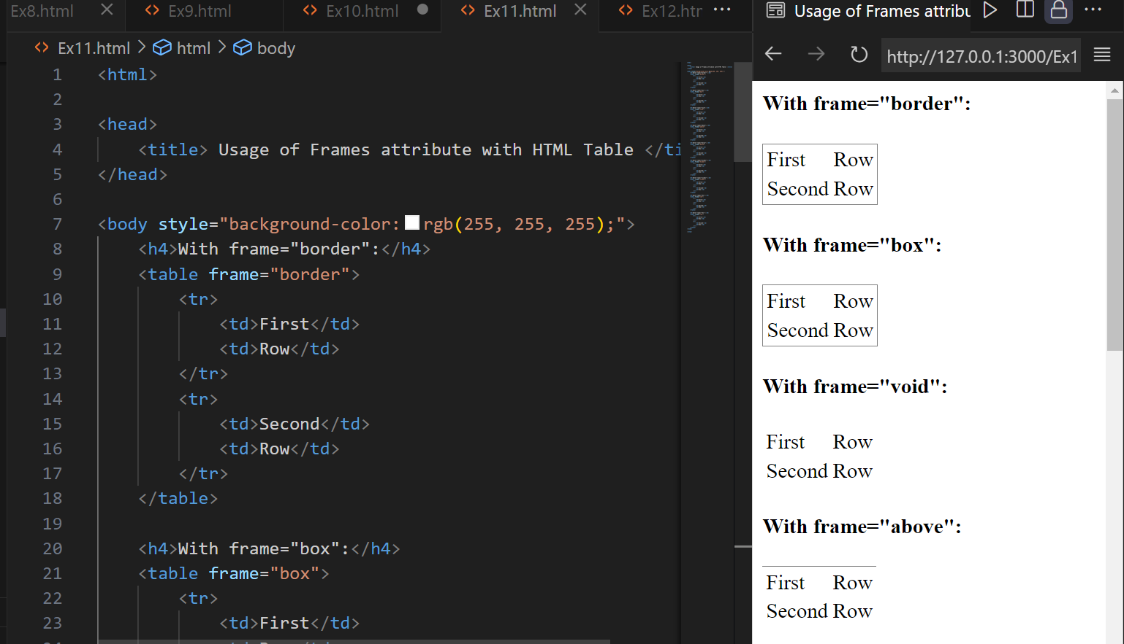
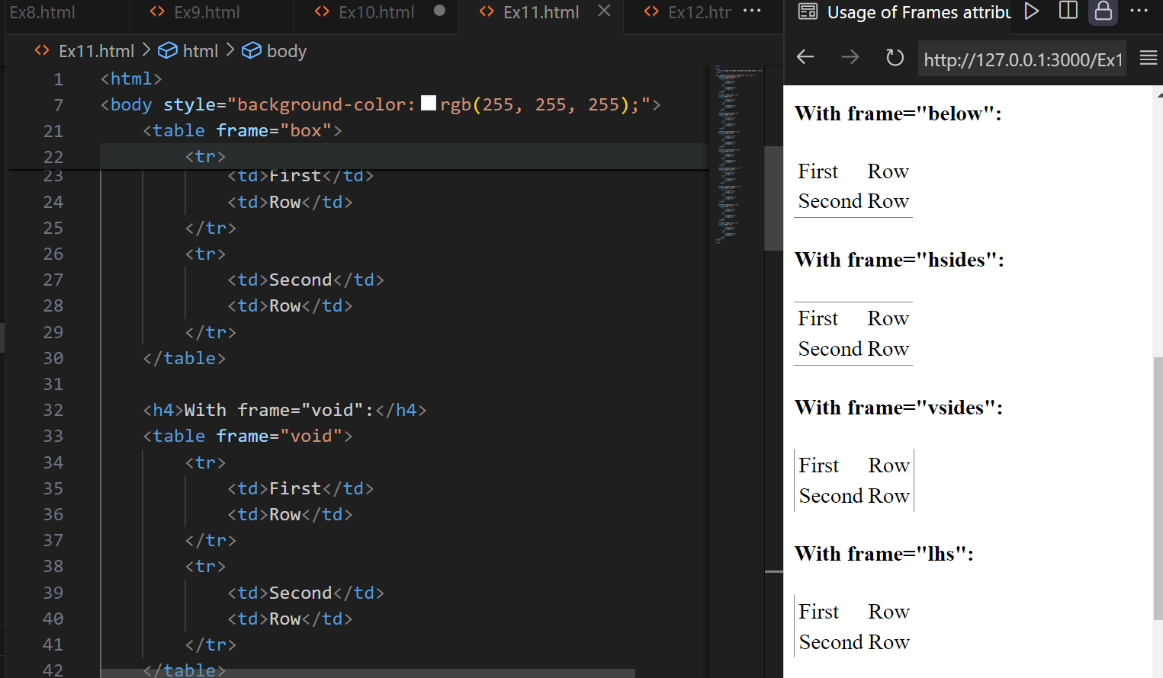

Example 12:
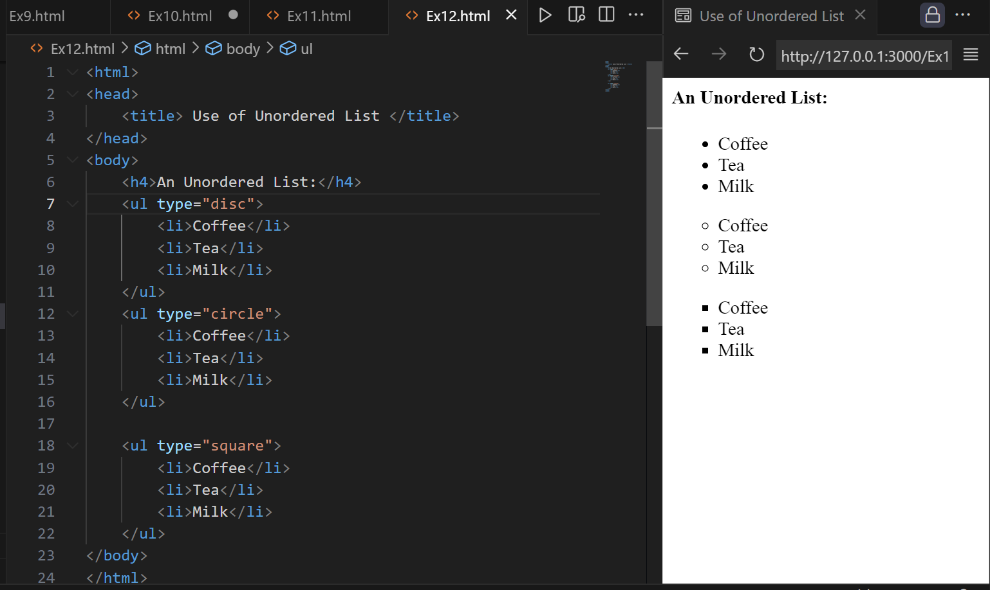

Example 13:
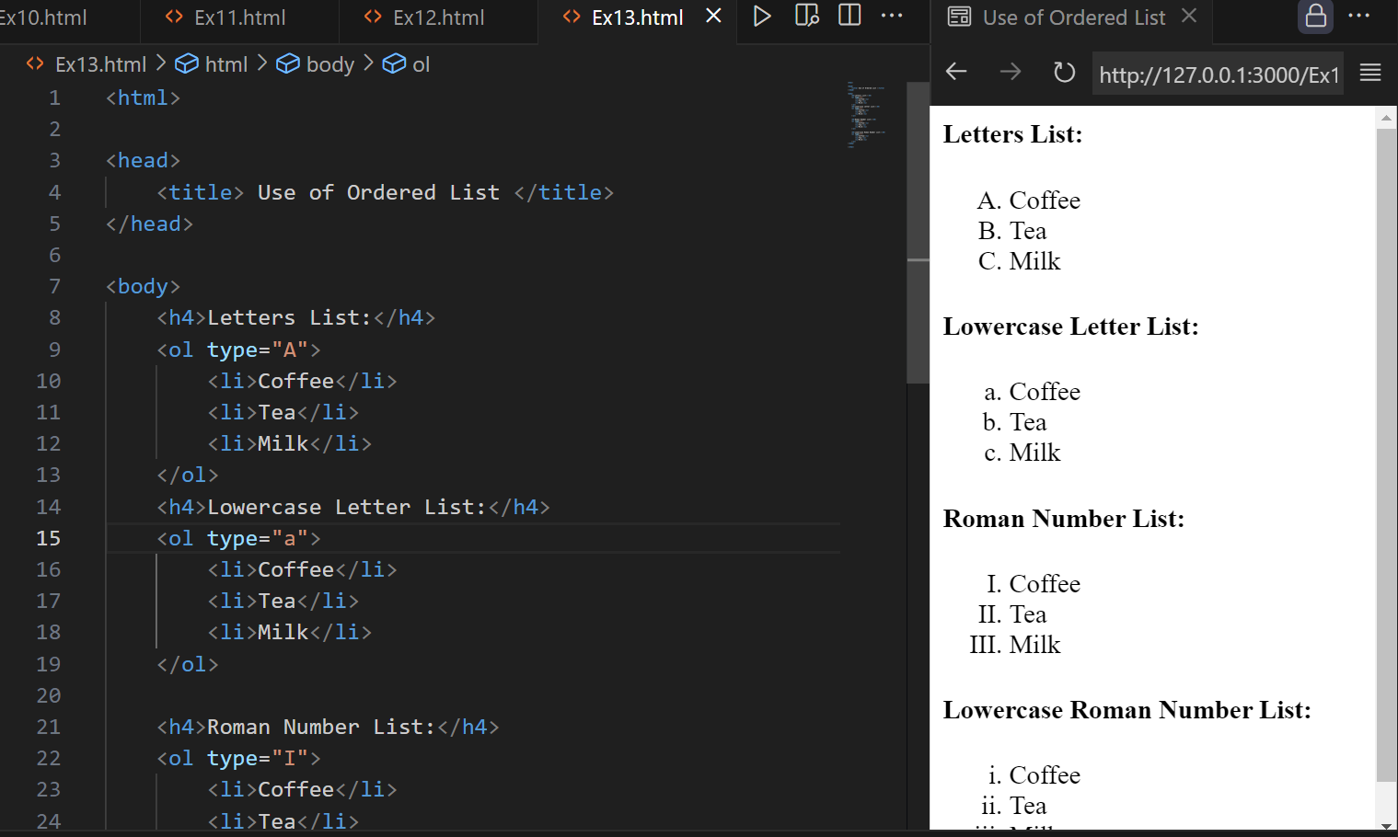

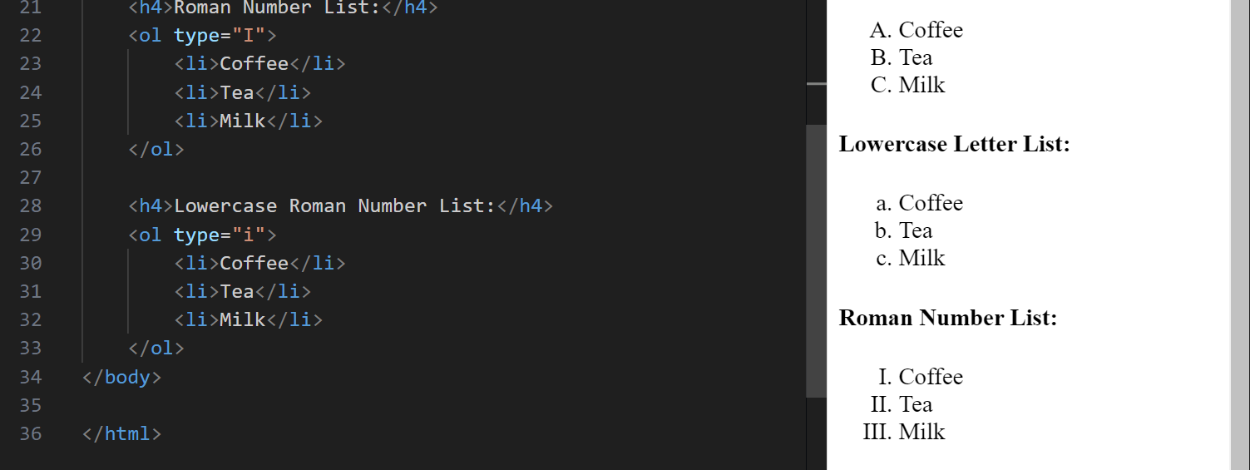

Example 14:
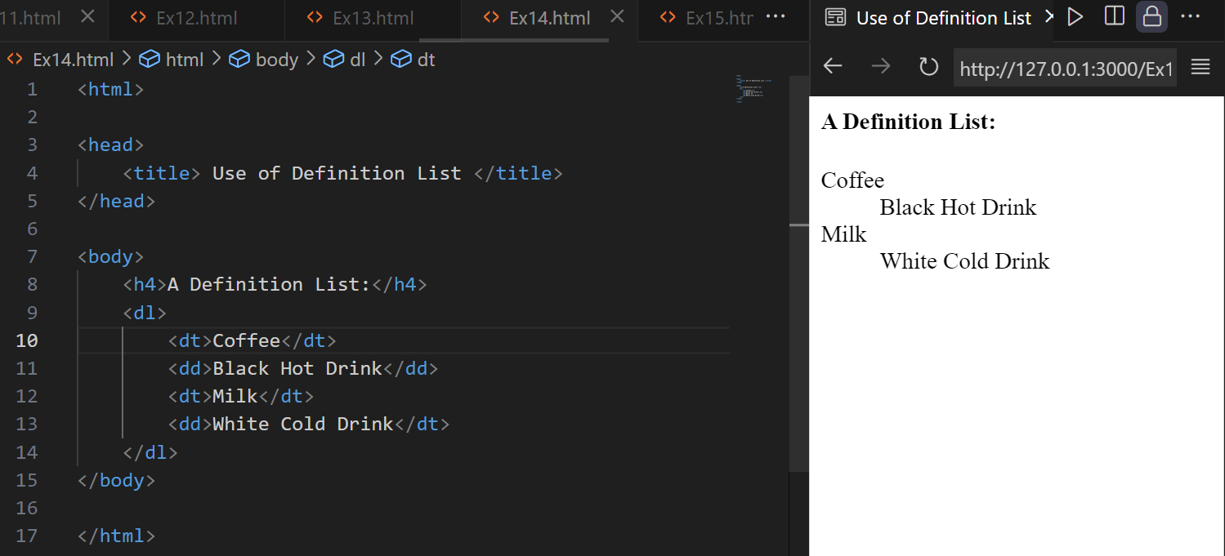

Example 15:
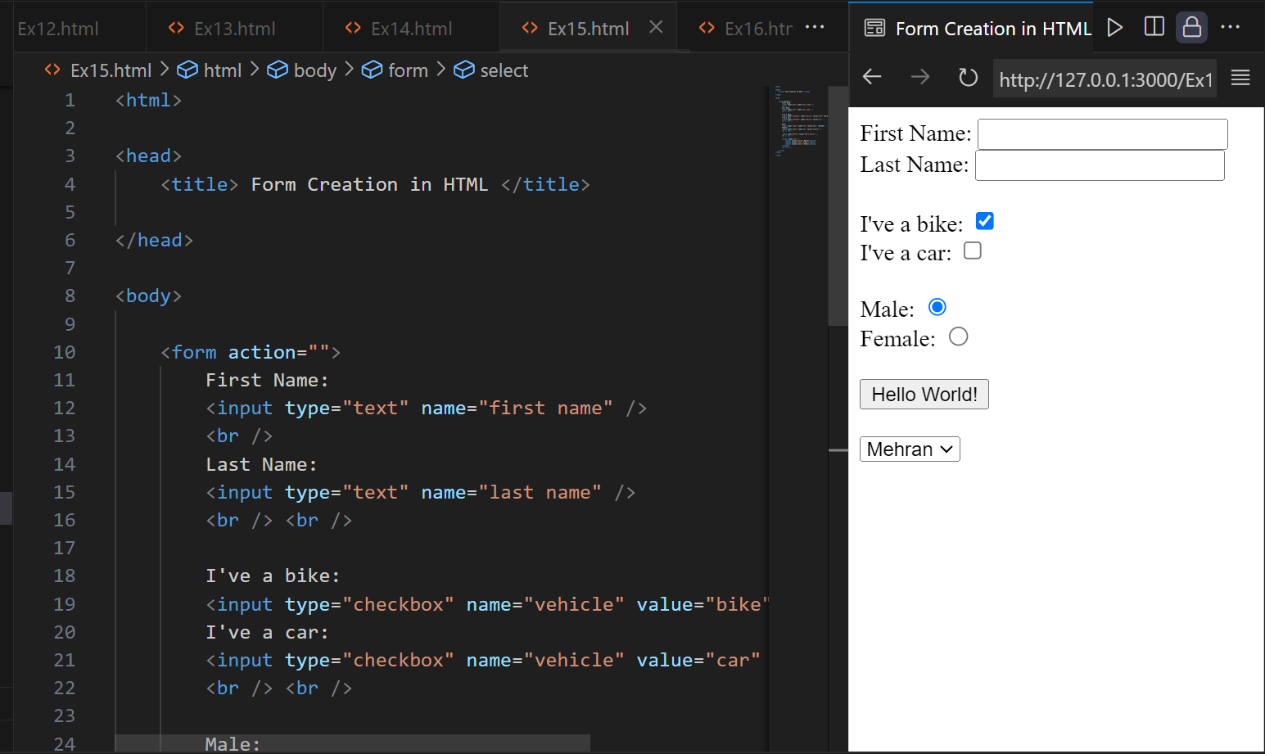
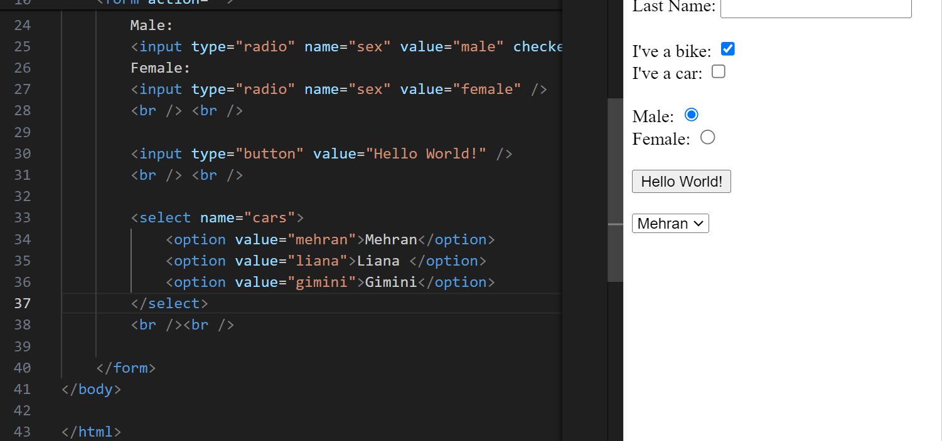

Example 16:
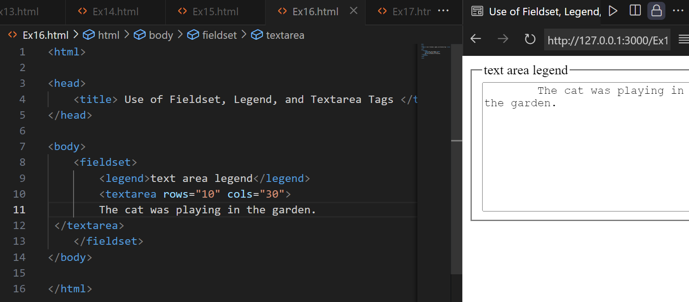

Example 17:
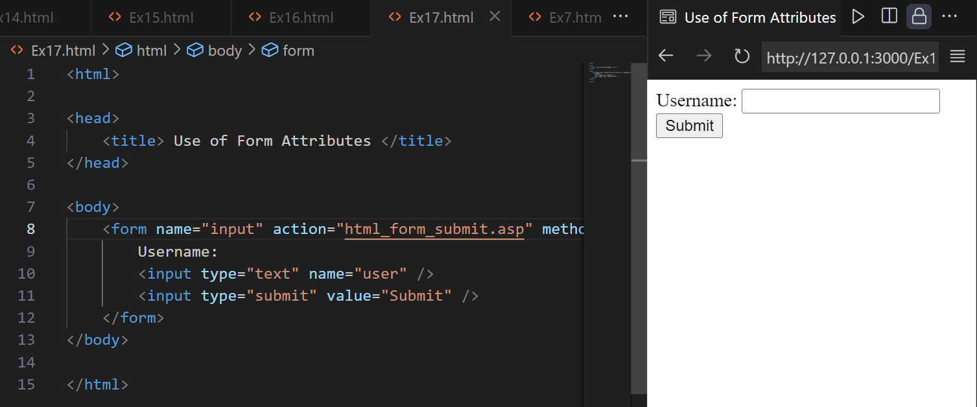

3. Hands-On: Create a basic web page for an application of your choice using HTML tags covered in this lab. Your web page can have a title, headings, paragraphs, lists, images, and links.

Code:
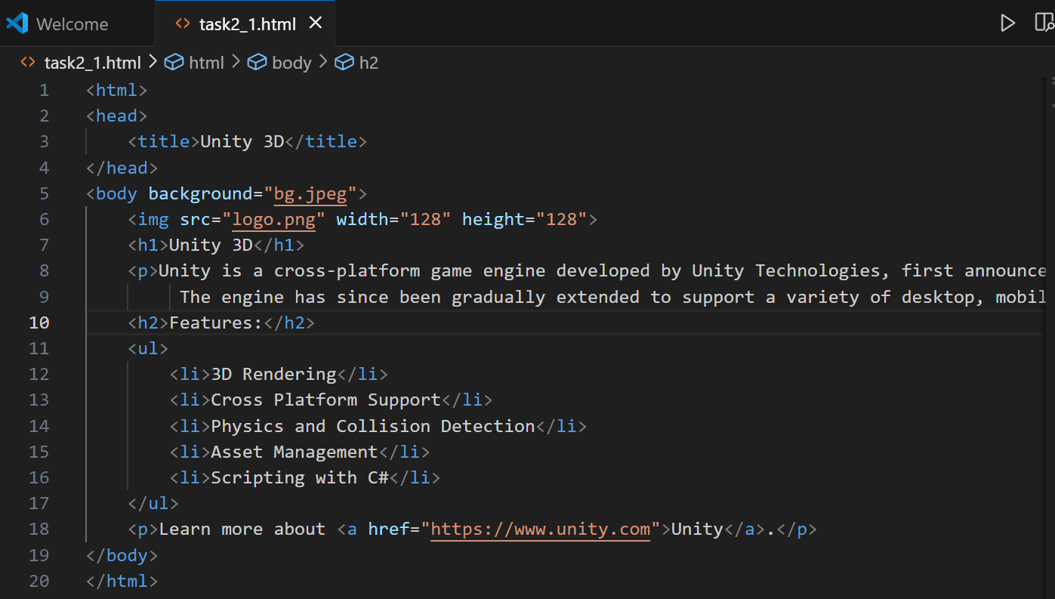
Output:
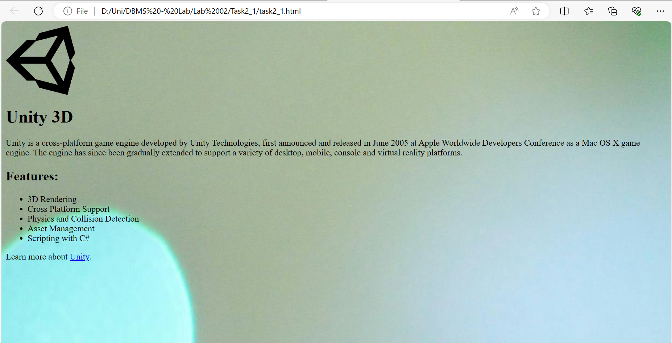
4. Evaluate yourself and write a note about your understanding of this lab.
Ans: Things Which I Learned and understood in this lab.
- Basic Syntax and Structure of HTML:
- Headings and Their Usage:
- Styling HTML Elements:
- Comments in HTML:
- Paragraphs and Formatting:
- HTML Styles:
- Creating and Formatting Tables:
- Creating and Formatting Lists:
- Forms for User Input:

5. Make DBMS Lab Project group and share the name and registration number of group members on the paper.
Ans: Names of our group members are:
- Shahzad Bangash(21PWCSE1980)
- Suleman Shah(21PWCSE1983)
- Ali Asghar(21PWCSE2059)

Task 2.2:
Code:
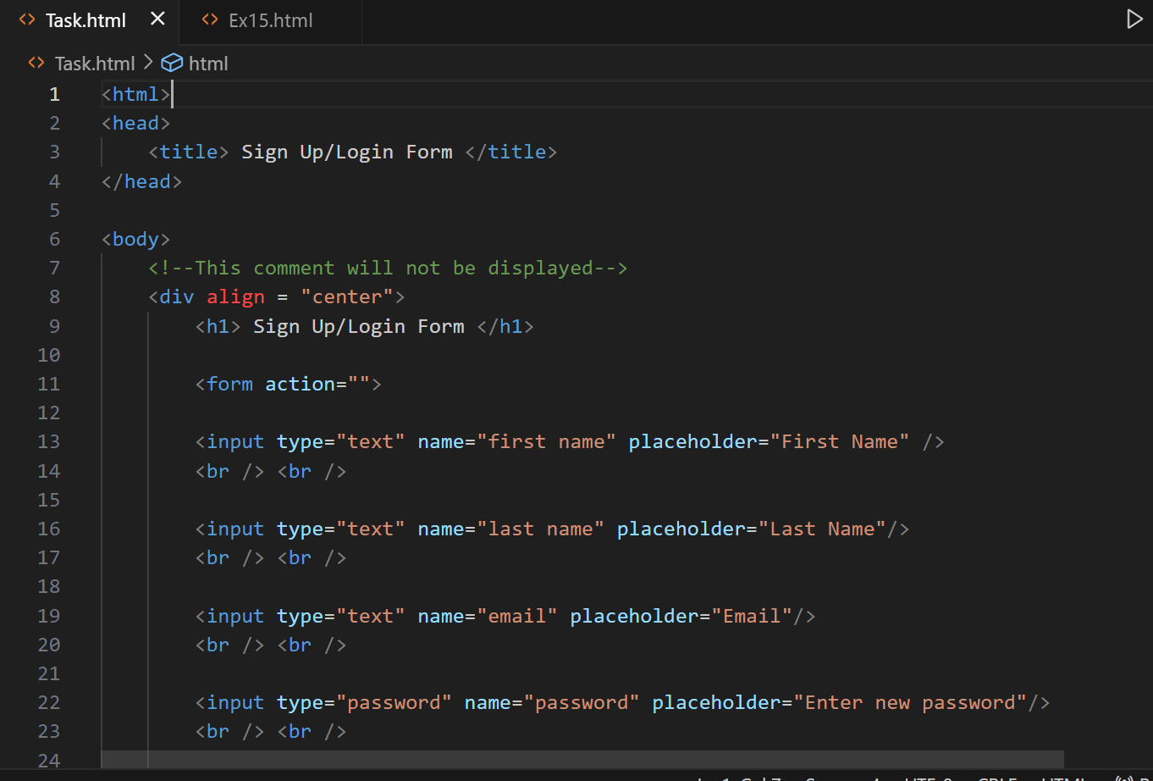
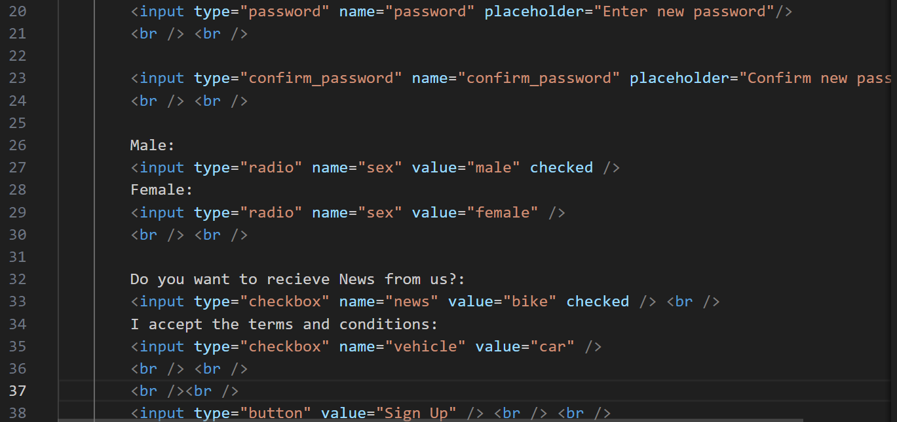
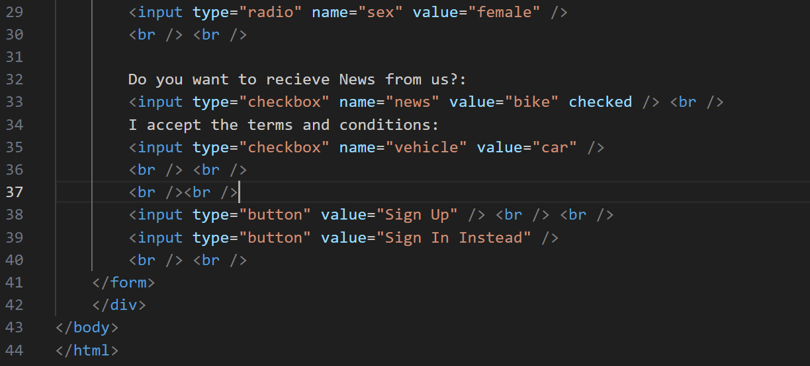
Output:
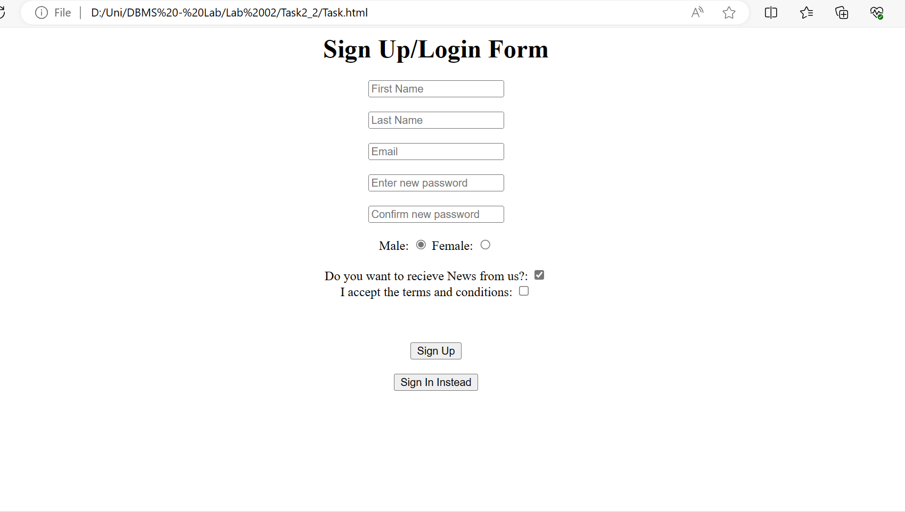

Task 2.3:
Code:
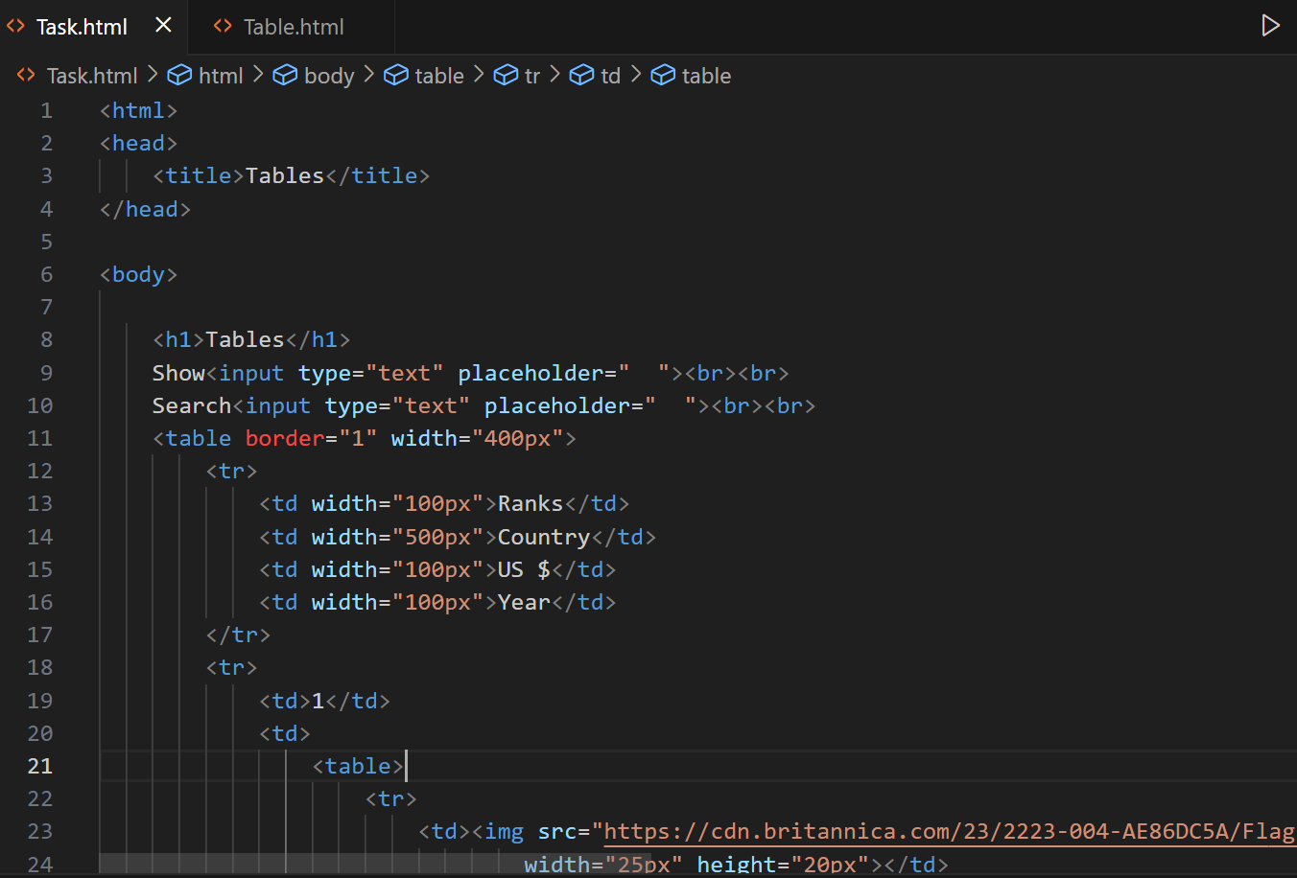

Output:
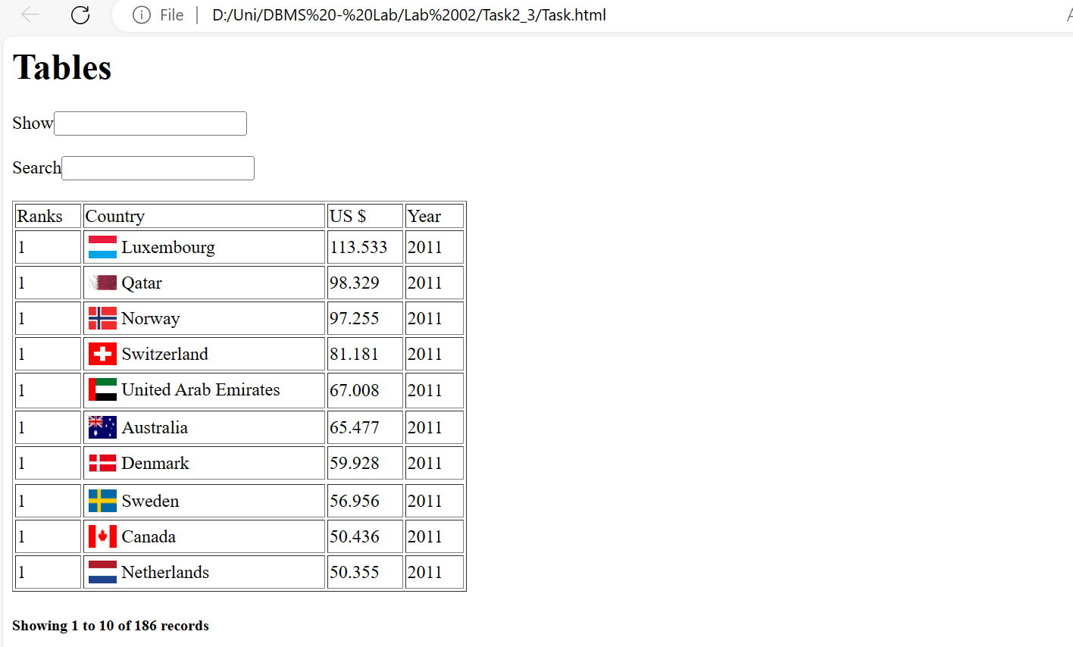

Task 2.4:
Audio and Video Tags:
HTML5 introduced the <audio> and <video> tags, allowing developers to embed audio and video content directly into web pages. We can use these tags to play audio files (such as music or podcasts) and video files (such as movies or tutorials).
Code:
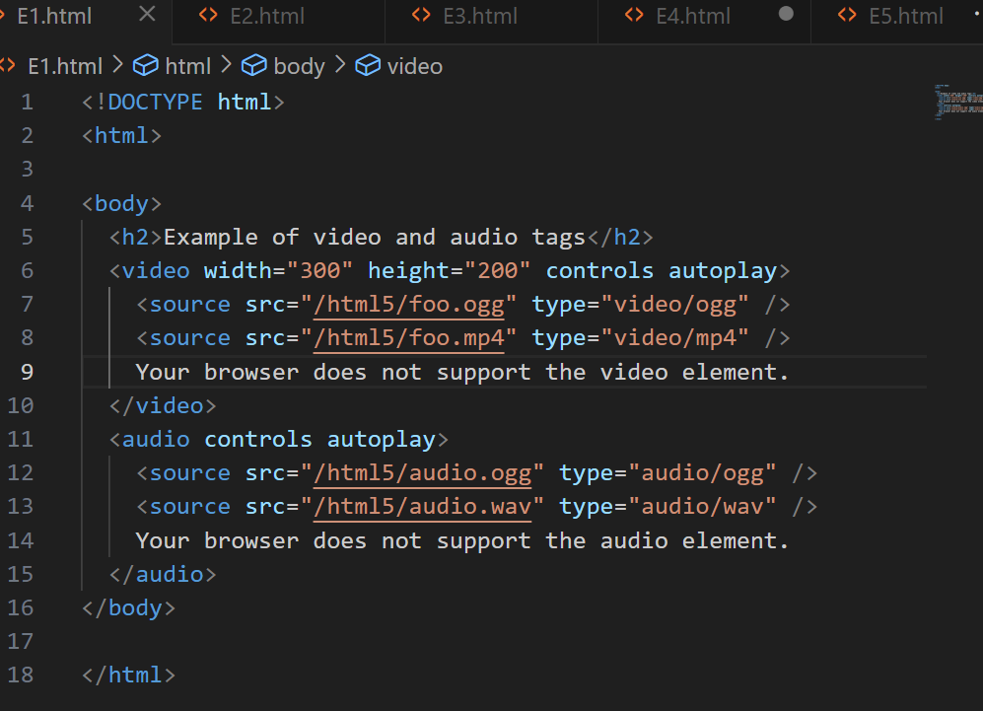
Output:
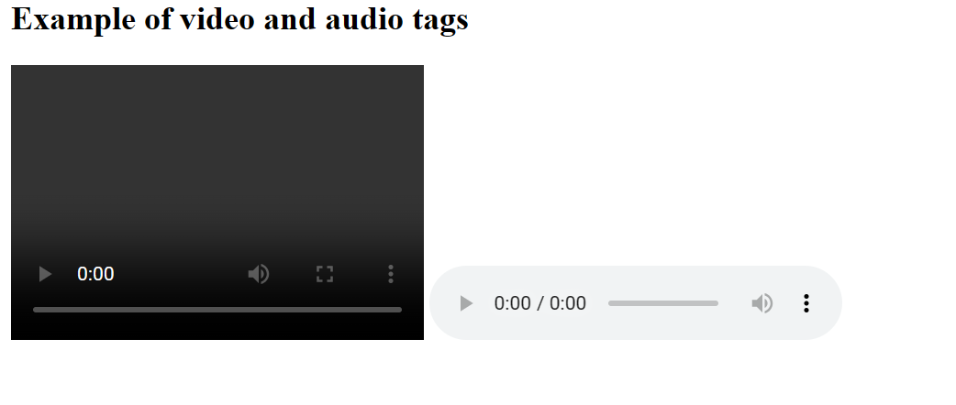
Vector Graphics (SVG):
Scalable Vector Graphics (SVG) is a powerful addition to HTML5. It allows us to create graphics with various shapes and colors using JavaScript. SVG graphics are scalable, easy to create, and editable. They also support interactivity and animation.
Code and output:
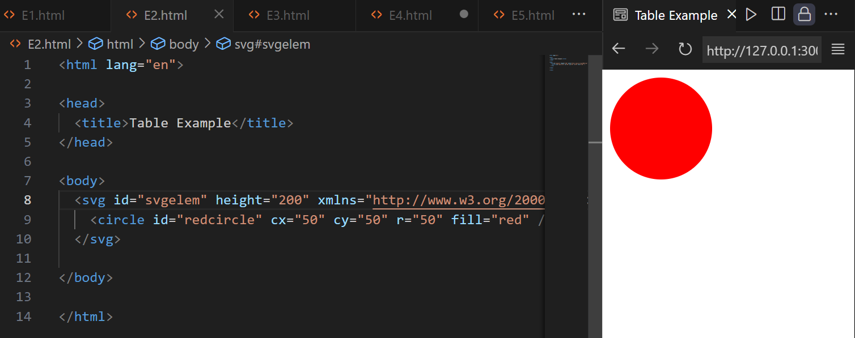

Header and Footer Elements:
HTML5 introduced semantic elements like <header> and <footer>. We can use <header> to define the header section of our web page (e.g., logo, authorship information), and <footer> for the footer section (e.g., copyright, contact information). These elements replace the need for <div> tags to identify header and footer sections.

Code and output:
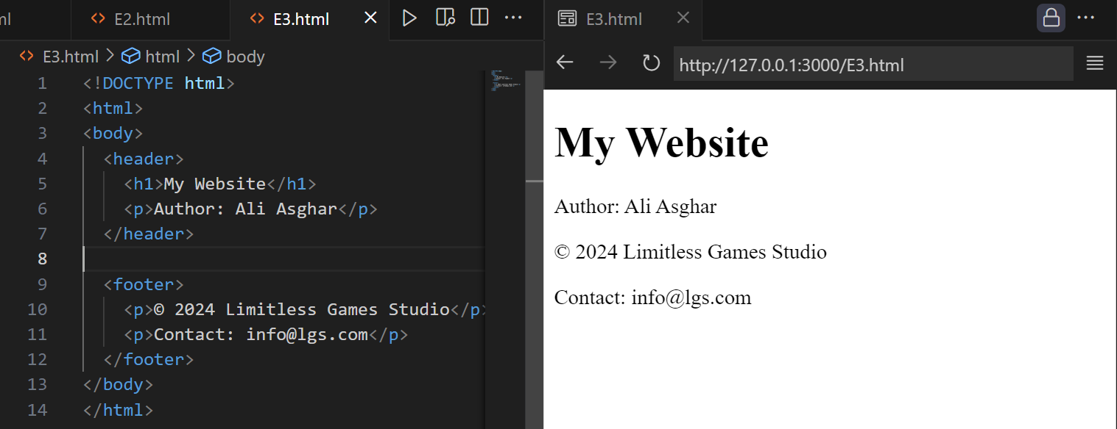

Canvas Element:
The <canvas> element allows dynamic rendering of graphics, animations, and interactive visualizations using JavaScript. We can draw shapes, images, and text directly on the canvas.

Code and output:
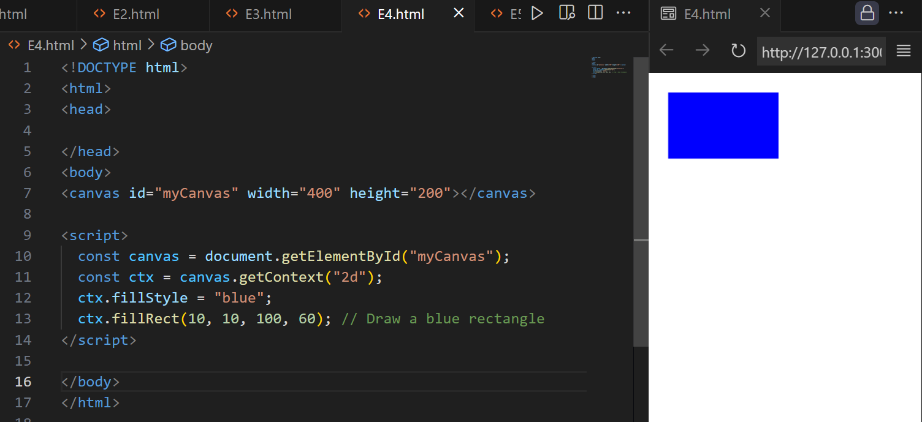
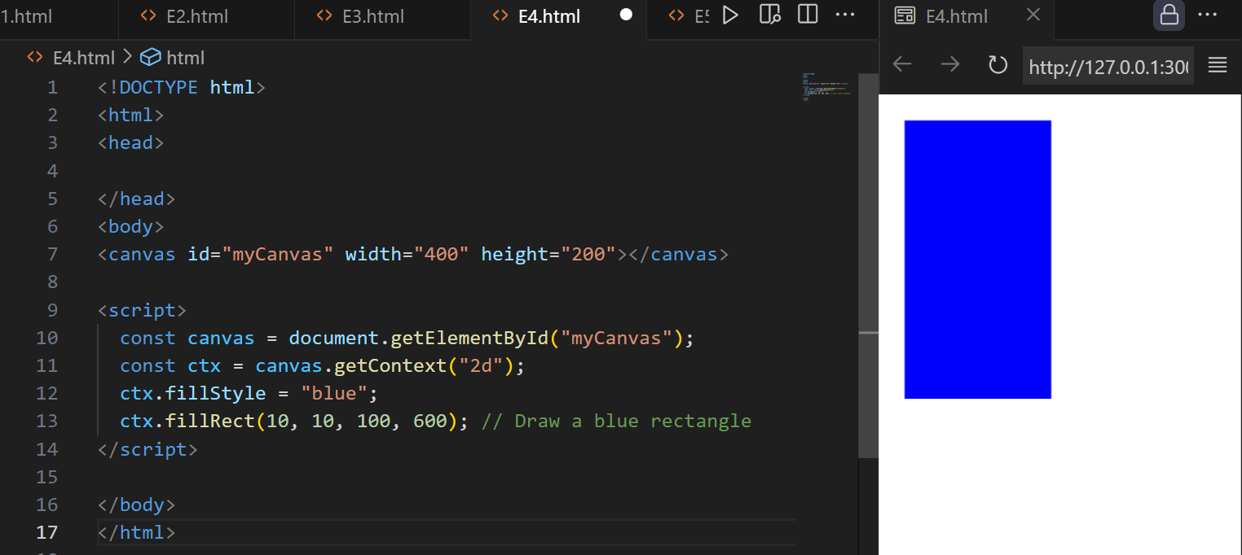
Geolocation feature:
HTML5 Geolocation feature allows us to determine a user’s geographical position. This feature is particularly useful for creating location-aware web applications. Here’s how it works:
- The HTML Geolocation API provides a way to retrieve the latitude and longitude coordinates of a user’s current location.
- Keep in mind that this feature requires user approval, as it can potentially compromise privacy.
- Geolocation is most accurate on devices with GPS capabilities, such as smartphones.
Code:
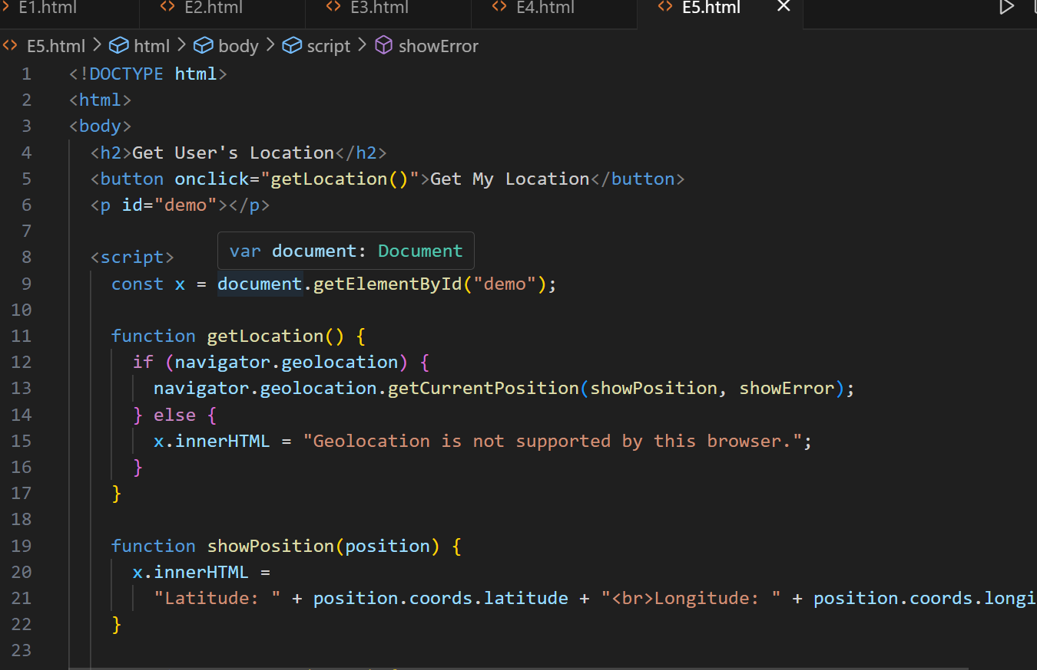
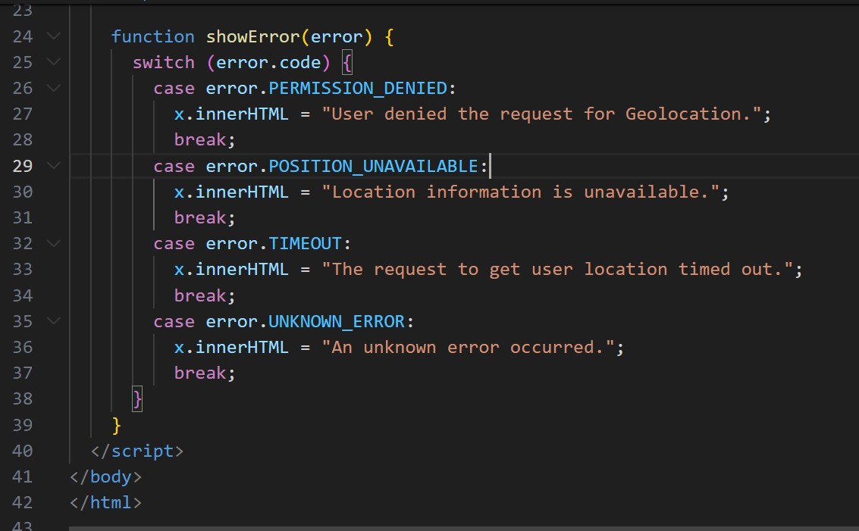

Output:
